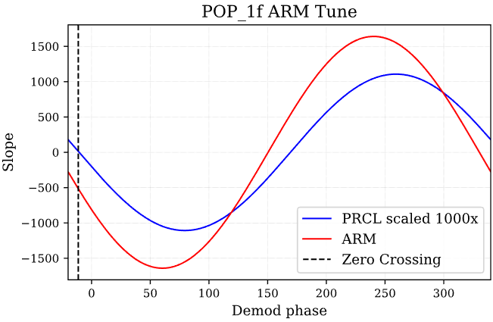

Max slope [259.19839679]

Stored 'refl_1f_PRM' (ndarray)

Max slope [240.44088176]

Stored 'refl_1f_PRM' (ndarray)

index no. of zeros [ 12 262]

First Zero crossing -11.342685370741481

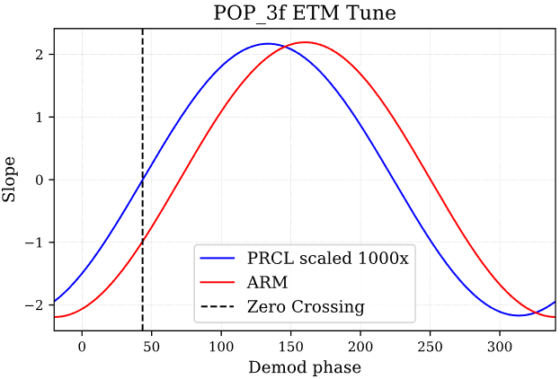

Max slope [133.66733467]

Stored 'refl_1f_PRM' (ndarray)

Max slope [160.36072144]

Stored 'refl_1f_PRM' (ndarray)

index no. of zeros [ 88 337]

First Zero crossing 43.4869739478958

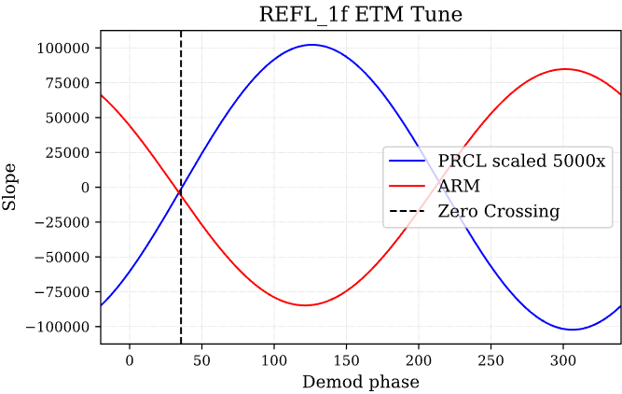

Max slope [126.45290581]

Stored 'refl_1f_PRM' (ndarray)

Max slope [301.76352705]

Stored 'refl_1f_PRM' (ndarray)

index no. of zeros [ 77 327]

First Zero crossing 35.55110220440882

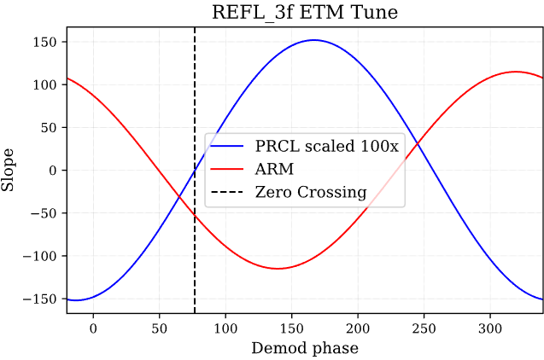

Max slope [166.85370741]

Stored 'refl_1f_PRM' (ndarray)

Max slope [319.07815631]

Stored 'refl_1f_PRM' (ndarray)

index no. of zeros [134 383]

First Zero crossing 76.67334669338678